HCS – NOTIFICATION FORM (WORKLIST) CHEAT SHEET
- The notification form (worklist) function in HCS is a helpful tool for providers to utilize to sign orders and review items without loading a patient set and patient profiles
- The worklist can be configured to load when providers log in, but it can also be manually loaded by clicking on the below icon on the patient banner
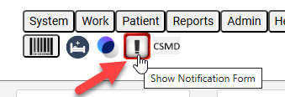
- When the worklist loads, it will show a list of patients that have items needing to be signed or reviewed based on what items are checked (most facilities would only need the options ‘With orders needing signature’ and ‘With observations needing review’). If you make any changes to the top checkboxes, you will need to click ‘Refresh’ for this to update the listed patients
  - When a patient is selected, you will have the option for Orders or Labs depending on what that patient has needing actions on. If you select the checkbox ‘Advance through Patients Automatically’, you can go to the next patient from the review or sign screen.
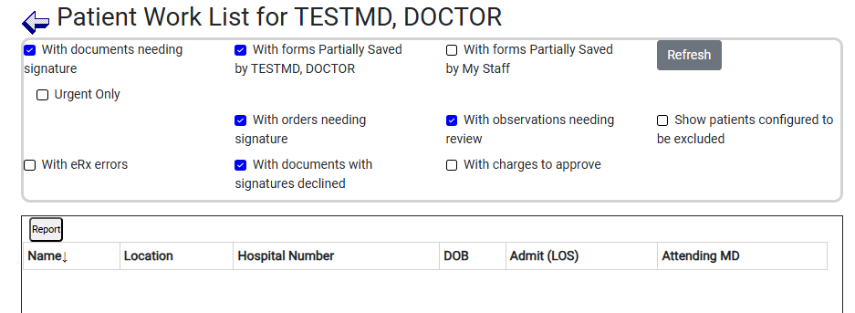

- The e-sign box will be similar to the box when signing orders from a patient profile. If your facility needs the default to be ‘All Orders Not e-Signed’ instead of ‘Just My Orders’, please submit a ticket through the UHS Help Desk: customer.support@uhsinc.com
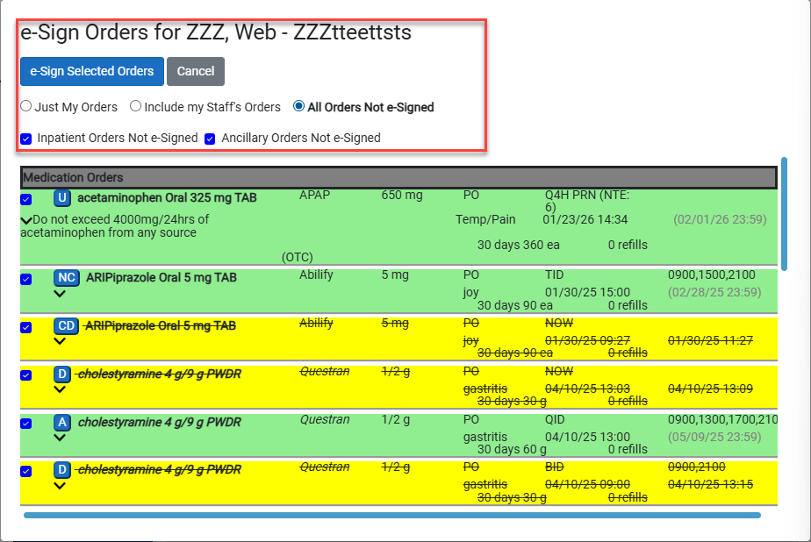
- After all items have been reviewed or all orders have been checked, you can select the ‘Next Patient’ or ‘e-Sign Selected Orders’ option to address these items and continue to the next patient. If you do not wish to continue to the next patient, you can select Cancel

